**Source code of lRegressor.cpp**

**#include <iostream>**

**#include <string>**

**#include <fstream>**

**#include <math.h>**

**using** **namespace** std;

**class** **LRegressor** {

**public**:

LRegressor() {r = 0;}

**int** calculateR(string input_file);

**double** getR() {**return** r;}

**private**:

**double** r;

};

**int** LRegressor::calculateR(string input_file) {

ifstream input;

input.open(input_file.c_str());

**double** x, y;

**double** Xp2, Yp2, XY;

**double** sumX = 0, sumY = 0, n = 0;

**double** sumXY = 0, sumXp2 = 0, sumYp2 = 0;

**double** num, denom;

**int** c = input.peek();

**if** (c == EOF || input.fail())

{

cout << input_file << " is empty or doesn't exist.\n";

**return** 0;

}

**while**(input.good() && c != EOF)

{

input >> x;

sumX += x;

sumXp2 += (x*x);

input >> y;

sumY += y;

sumYp2 += (y*y);

sumXY += (x*y);

n++;

c = input.peek();

}

num = n * sumXY - sumX * sumY;

denom = sqrt((n * sumXp2 - pow(sumX, 2)) * (n * sumYp2 - pow(sumY, 2)));

r = num / denom;

**return** 1;

}

**int** main (**int** argc, **char**\* argv[]) {

string filename;

**if**(argc == 1)

filename = "input.txt";

**else**

filename = string(argv[2]);

LRegressor LR;

**int** code = LR.calculateR(filename);

**if**(code == 0)

**return** 0;

**double** R = LR.getR();

cout << "Calculcation done!\n";

cout << "R: " << R << "\n";

cout << "R^2(Correlation): " << pow(R, 2) << "\n";

**return** 1;

}

**Use-Case Diagram**

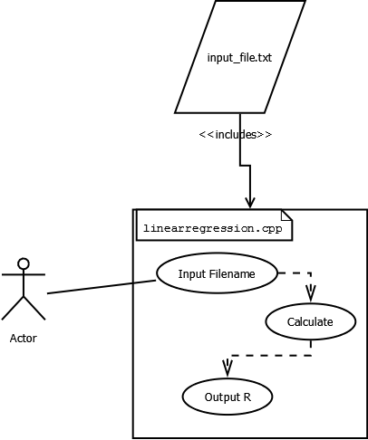

**UML Class Diagram**

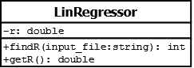

**Screen Capture of Program Compiling and Running**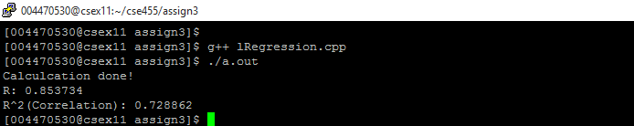

**Output Table**

|  |  |  |  |  |  |
| --- | --- | --- | --- | --- | --- |
| **Expected Values** | | | **Actual Values** | | |
| r | r2 (correlation) |  | r | r2 (correlation) |  |
| 0.846 | 0.715 | 0.854 | 0.729 |

**Assignment #3**

Seth Lemanek

Dr. Arturo Concepcion

February 14, 2016